AIML ASSIGNMENT

CLEAN WATER AND SANITATION

(SDG 6)

Clean water is important to public health and helps reduce waterborne diseases, enhances child development, and improves quality of life. Clean water prevents a host of illnesses, such as cholera and typhoid, that decrease healthcare costs, enhance community productivity, and support education because children, particularly girls, spend less time fetching water. It also helps protect ecosystems, ensuring sustainability and biodiversity. It is true that investment in water infrastructure and pollution control is an important requirement for public health, economic stability, and realization of sustainable development. AI supports by monitoring the quality of water, anticipating the extent of pollution, and optimizing the resources, ensuring sustainable access and safety.

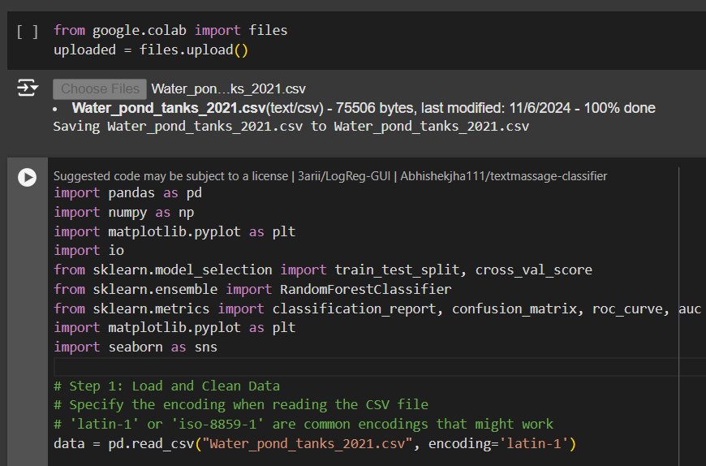

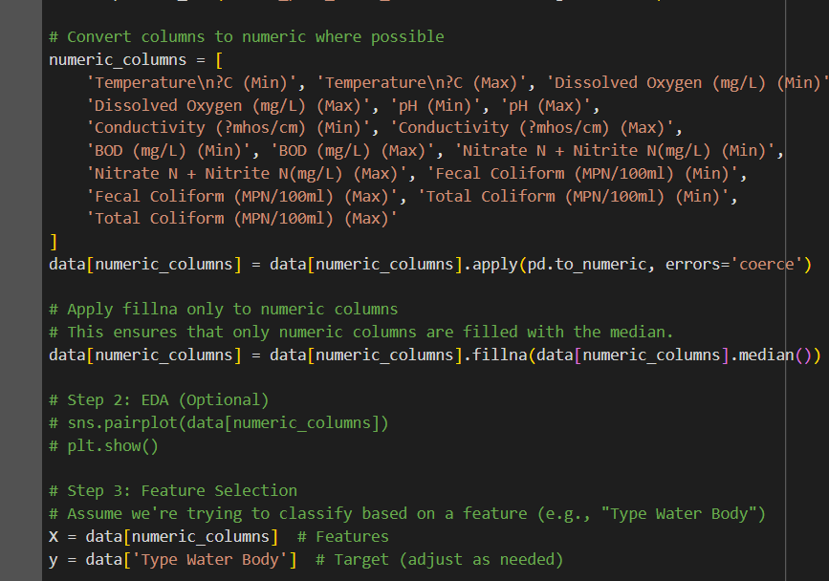

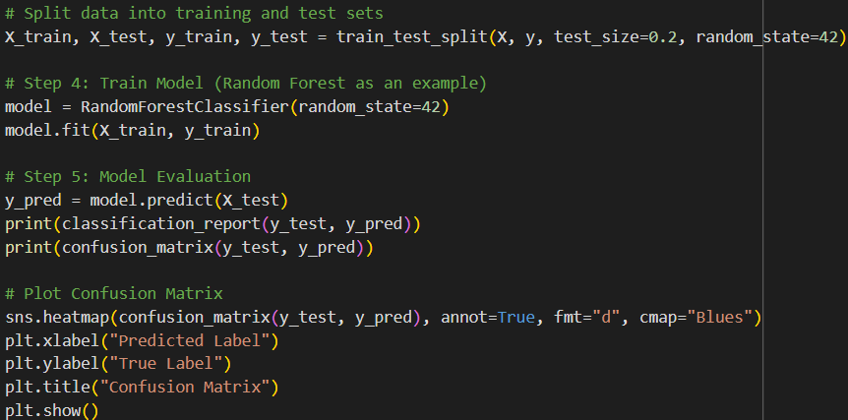

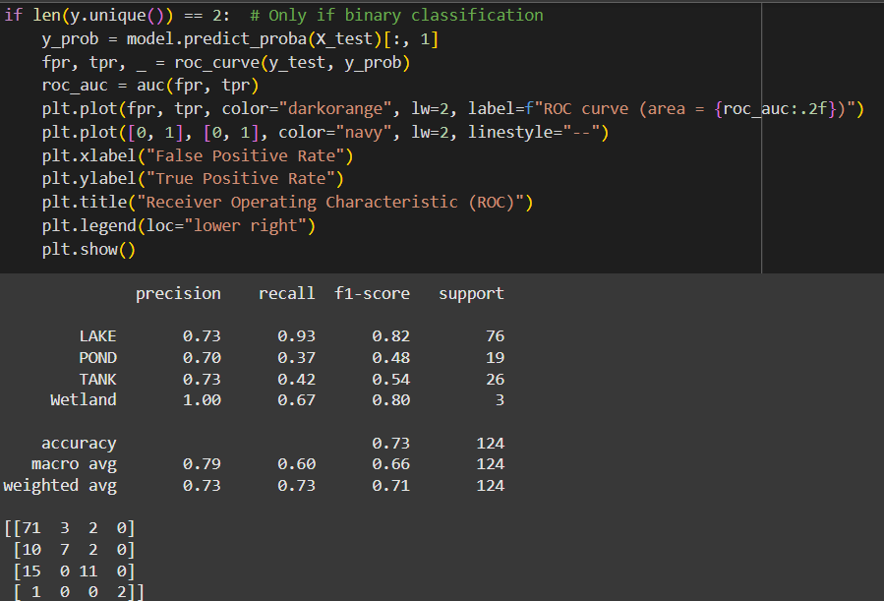

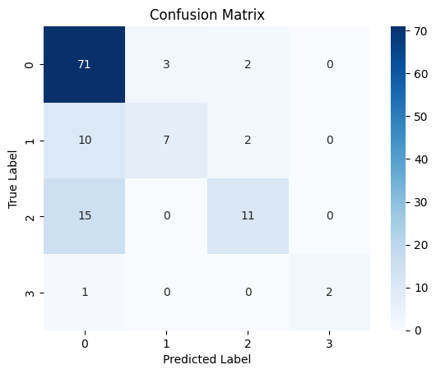



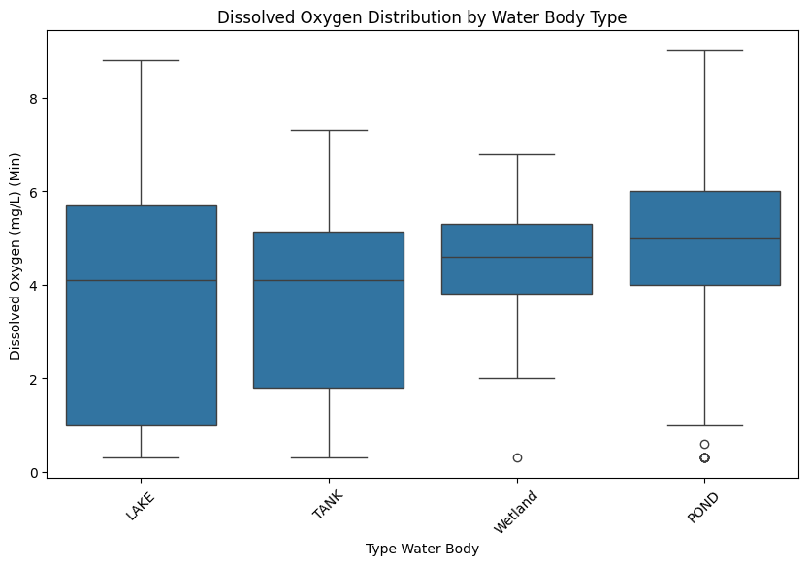



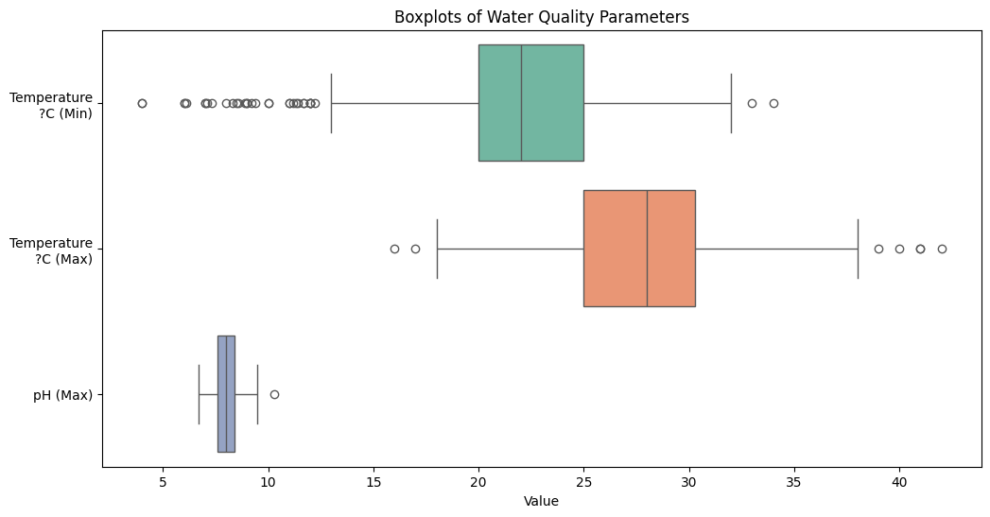

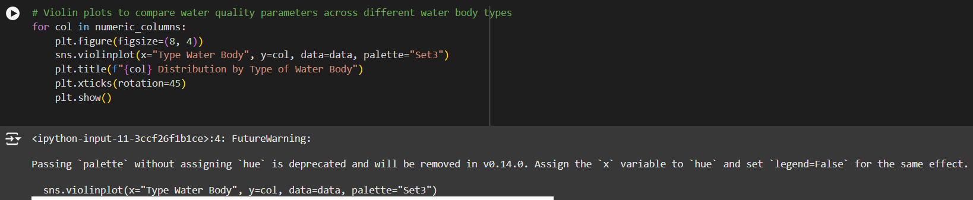

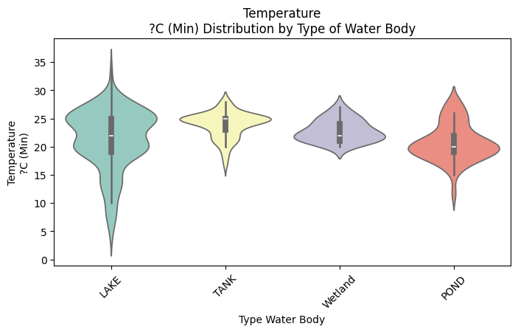

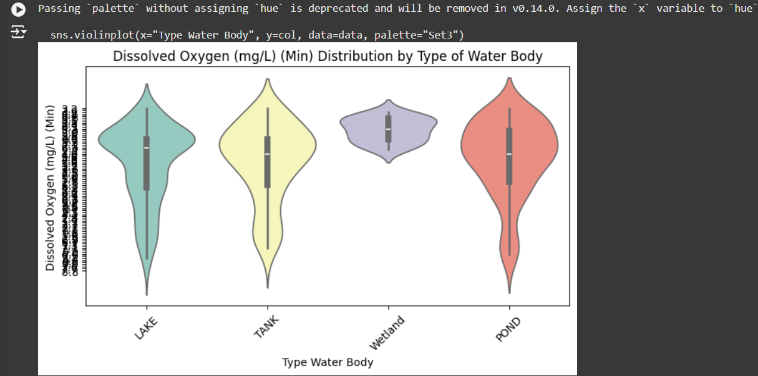

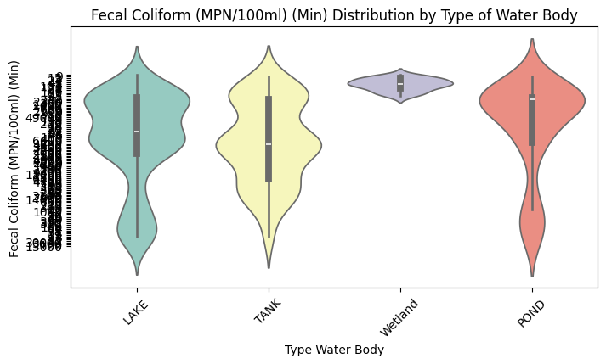

The Random Forest model for water quality classification has far-reaching social implications as it encourages enhanced public health, environmental protection, and economic activities.

Main Advantages:

Enhancing Public Health and Safety: Benefits of early detection of any contamination include limiting access to unsafe levels of water and treating people exposed to waterborne illnesses.

Enhancing the Quality of Environment: Protects all forms of life by promoting high-quality water and limiting the influx of harmful substances in the environment.

Advancing the Sustainable Development Goals: Advocates for SDG 6 on Clean Water and Sanitation, SDG 3 on Good Health and Well-Being, and SDG 14, which deals with Life Below Water.

Contributing to the Formulation of Public Policy and the Utilization of Resources: Efficiently targets environmental concentrations and encourages resource efficient policies.

Promoting Public Science Awareness and Participation: Making reports available to the public and promoting local involvement.

Contributing to Agriculture and Economic Sustainability: Provides adequate quality of irrigation water in agriculture and helps preserve their recreational waters for the local economy.

Supporting Scholarship and Demand-oriented Technology Development: Stimulates the development of water management solutions.

Illustration in Practice:

A coastal community implemented the model to detect contamination, in clean-up, and public education, which improved the health and economy.

The model allows for measures to be taken to make the world cleaner, safer and more resilient.

It’s no surprise that clean water is essential not only to human health and wellbeing but also to economic growth and environmental sustainability. i It fights diseases, promotes healthy childhood growth, and improves the very quality of life. Any community, which lacks clean water, faces a great risk in terms of health, economic, or even environmental aspects.

Specifically, this system can further improve water quality through water quality monitoring, water contaminant prediction capabilities, and optimized water intake. AI helps us to deliver, use and manage safe drinking water in a more efficient manner through the use of targeted, cost-effective measures and sustainable provision of access.